**Lucknow public college of professional studies**



**PROJECT REPORT**

**ON**

**“Algorithm visualizer”**

**OF**

**BACHELOR OF COMPUTER APPLICATION**

**FROM**

**UNIVERSITY OF LUCKNOW**

**DEPARTMENT OF COMPUTER APPLICATIONS**

**SUBMITTED BY: SUBMITTED TO:**

**UJJWAL KUMAR K. S. AWASTHI**

**ROLL NO: 2110820580098**

**ACADEMIC SESSION 2021-2024**

**ACKNOWLEDGEMENT**

While making this file, I have Referred to various source and have freely used the writing of the outstanding scholars and researches. I hereby acknowledge to all author of the books and researches I have referred, mentioned in the bibliography.

I express my deepest gratitude to the my subject teacher Dr. Akhilesh sir and faculty member Dr. K. S. AWASTHI.

Awasthi Sir,

I heartily thank my parent for their blessing, my family for their assistance love and inspiration throughout my life. Special thanks to my brother who has continued to provide me with better ideas that has helped mean lot I am also thankful to my friends and colleagues for their help and suggestions that I have received during my work.

Above all, I thank the almighty GOD, for giving me the immense strength and wisdom to be dedicated in my work and give my best.

THANK YOU.

**-UJJWAL KUMAR**

**CERTIFICATE OF ORIGINALITY**



This is to certify that the project report entitled “**Algorithm Visualizer**” submitted to **Lucknow Public College of Professional Studies** affiliated from **University of Lucknow** in partial of requirement for the award of the degree of **Bachelor of Computer Application (BCA)**, is an authentic and original work carried out by **Mr. Ujjwal kumar** with enrolment no. **2110820580098**. Under my guidance the matter embodies in this project is genuine work done by the student and has not been submitted whether to the University or to any University/Institute for the fulfilment of any course of study.

**Signature of Student Signature of Guide**

**Date: Date:**

**Algorithm Visualizer**

**TABLE OF CONTENTS**

**DECLARATION**

I have declared that this project report on, **“Algorithm Visualizer”** based on **HTML5, CSS4 and JAVASCRIPT** is to dedicated to visualize the algorithm to understandable for non-tech and tech background people, which is being submitted in partial fulfilment of the Training Program in Information Technology Application, it is the result of the work carried out by me, under the guidance of **Mr. K. S. AWASTHI** I.T faculty of **LUCKNOW PUBLIC COLLEGE OF PROFESSIONAL STUDIES, LUCKNOW**

**PREFACE**

It is great pleasure to us to present this software which is developed by our team of two member. The project is in my curriculum of live project in B.C.A. I thank to all member of Computer science Department who guide me for this project. I try to make it as a real project for Institute. Some salient features of this project are as fallows.

Even though there is so some chance to modification but we hope that we will able to fulfil the our goals. In future, we will plan to scale this project by which real life problem solved.

**INDEX**

|  |  |  |
| --- | --- | --- |
| **S. No** | **Title** | **Page No** |
| 1 | Synopsis |  |
| 2 | Introduction |  |
| 3 | Objective |  |
| 4 | System Analysis |  |
| 5 | Feasibility study |  |
| 6 | Software Requirement Specification |  |
| 7 | System Design |  |
| 8 | Software Engineering Paradigm |  |
| 9 | Literacy Survey |  |
| 10 | Coding |  |
| 11 | User Interface |  |
| 12 | Testing and Debugging |  |
| 13 | Error Handling |  |
| 14 | Validation Checks |  |
| 15 | Scope |  |
| 16 | Bibliography |  |

**SYNOPSIS**

**Introduction -**

**A**lgorithm visualizer is incredible web app that interact with algorithm and visualize them. This web application brings simplicity in understanding for complex algorithm for non-tech and tech people. We have created interactive interface by which user can use without any disturbance. With its intuitive interface and various features and user can contact me and suggest me to extra update and modifications.

**Objective -**

1. **Learning approach:** The main objective of this web application is to advance learning of any computer algorithm in a fine manner. Through my interactive web app, college students or any other background student who want learn the computer skill like sorting concepts, tree concept and graph concept .They can

learn all the above through this platform. I will add bit more algorithm in future.

1. **Accessible**: Algorithm visualizer also known as **vrittiviz** which is accessible to anyone there is no specific requirement because this is only for learning purpose. And also user can access this web application by any device whether you have mobile, laptop and desktop. This will work smoothly on all the devices.
2. **Easy to Understand:** I strongly promise that once you have use my website then you recommend all the friends to help to understand the complex algorithm in easy block representation fully imaginable.

**Software & Hardware Requirement**

**Software Requirements**

1. **Integrated Development Environment(IDE)**

**VS Code:** Visual Studio Code is source-code editor developed by

Microsoft for windows and mac. It includes all the tools needed for

developing the web app and application.

2. **Programming Language**

**HTML5 :** HTML5 is version 5 popular markup language to create web pages and html is skeleton of the web pages.

**CSS3 :** CSS3 is version 3 something popular style sheet language. It

used for styling for web pages and describing the presentation of a document written in a markup language such as HTML or XML.

**JavaScript**: JavaScript is programming language that is one of the core technologies of the world wide web, alongside HTML and CSS. As 2023, 98.7% of websites use JavaScript on the client side webpage behaviour.

**3. Graphic Design Software**

**Figma:** Graphic design tool for creating interactive web pages. It includes all essential to style the web app.

**4. Version Control**

**Git:** Utilize Git for version control to manage and track changes in your source code.

**Hardware Requirement:**

**Modules:**

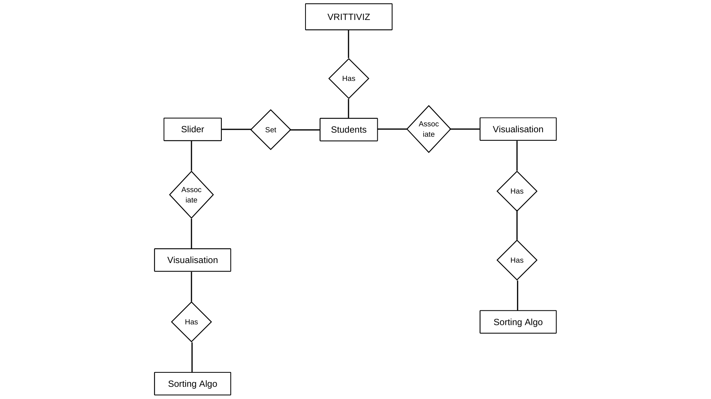**ER Diagram**